# **PRESS RELEASE**

# **Camdenton R-III School District Education Foundation, Inc.**

#### P O Box 1409 – Camdenton, MO 65020 – 573.346.9213

*“Steering the Course for the Future”*



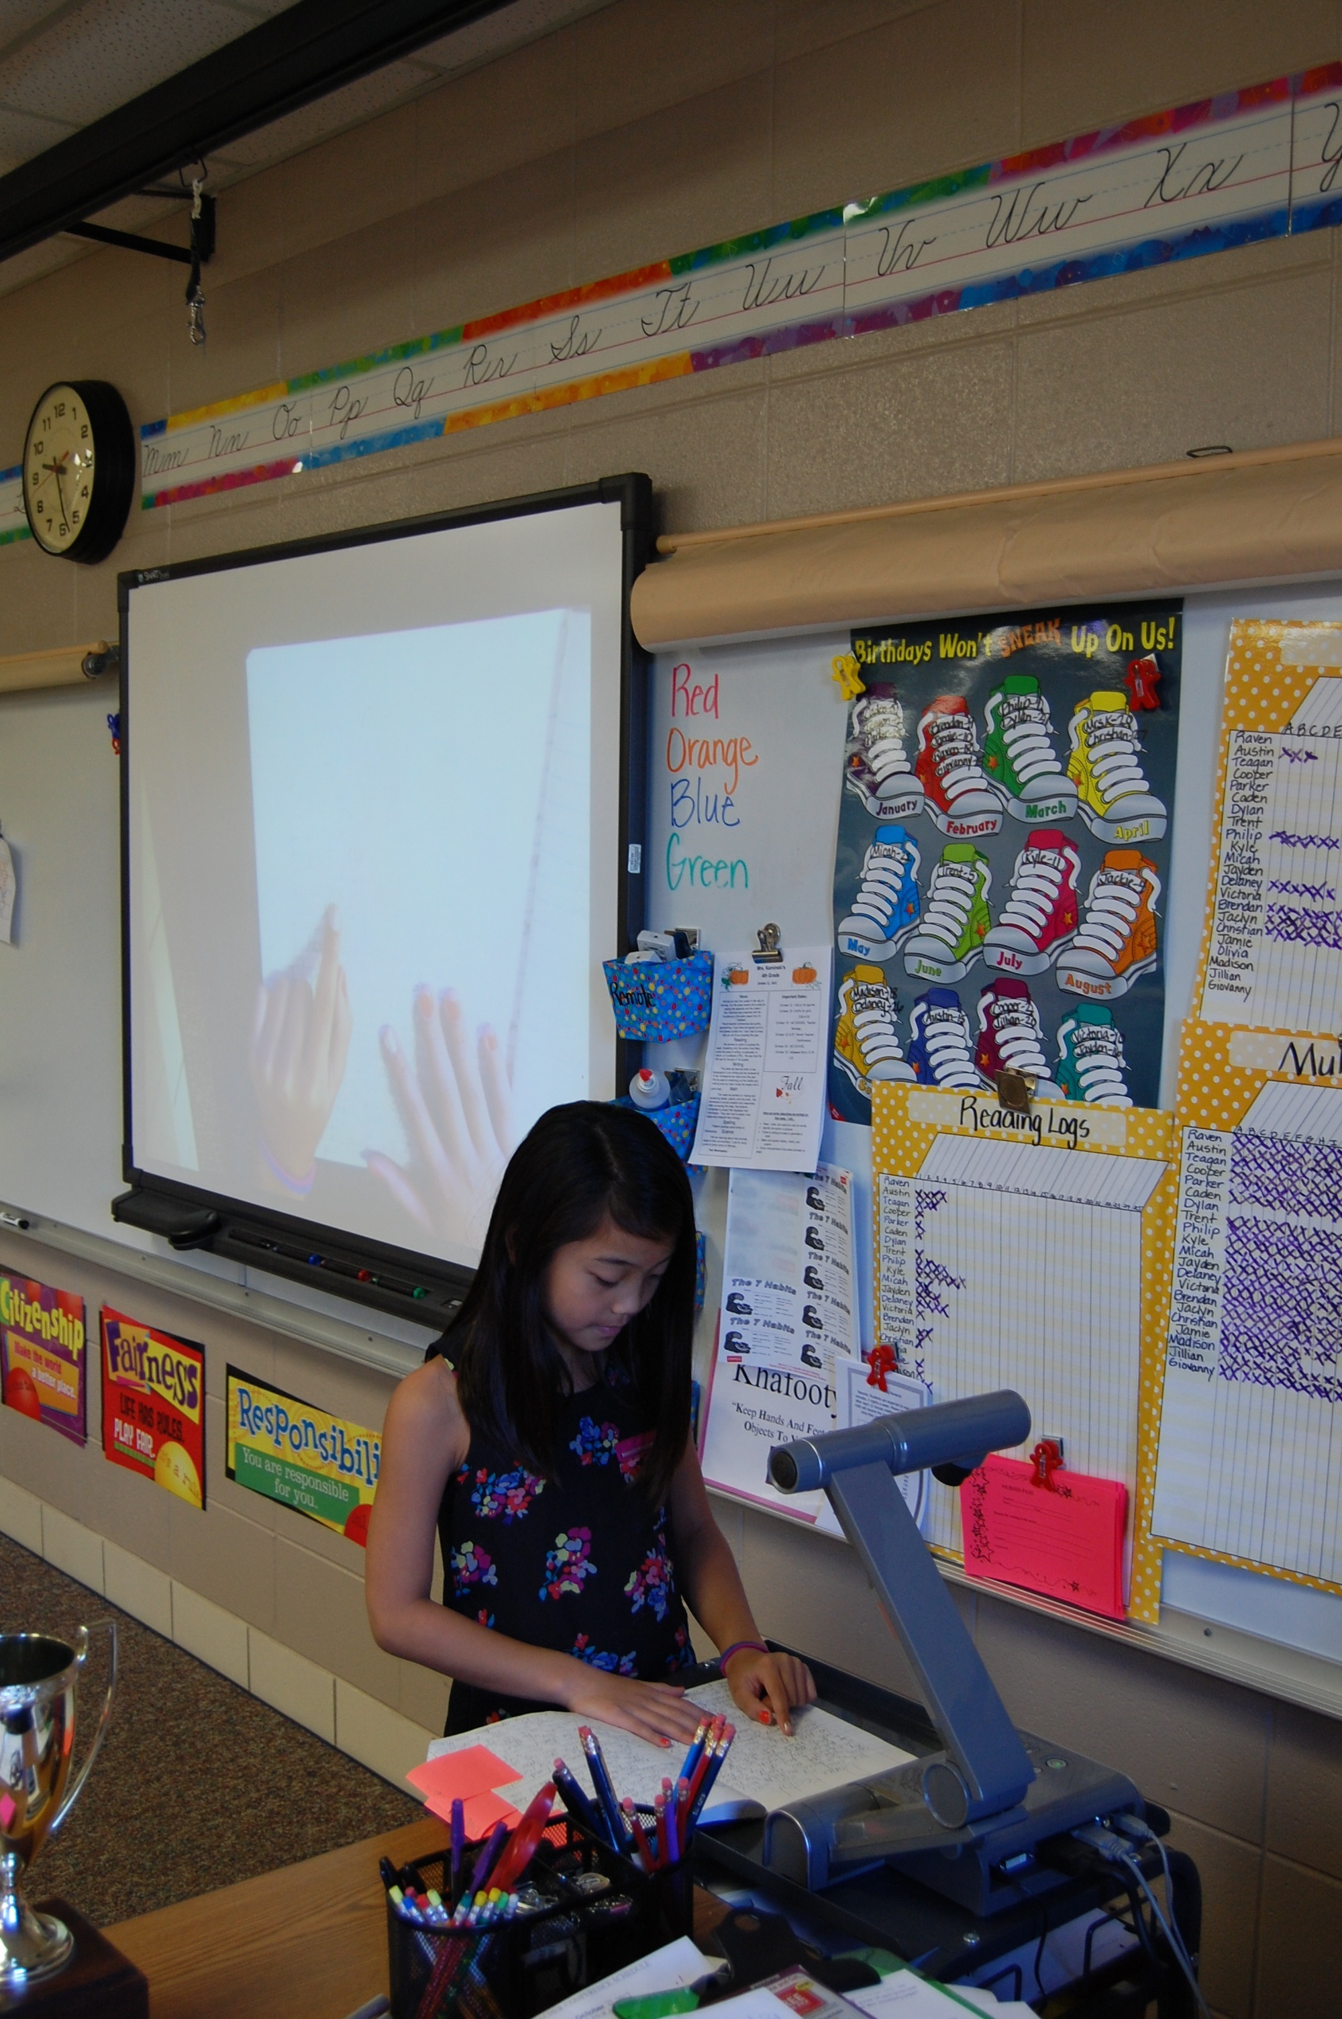

**SMART Document Camera Transforms Classroom Presentations**

Osage Beach Elementary (OBE) Educator Erin Kaminski has been anxious for her students to experience using a SMART Document Camera for some time now.

“Technology is a huge motivator in the classroom,” reports Kaminski. “I knew the document camera would reach all my visual learners. It motivates more students to share when they get to use the camera themselves.”

Due to a special grant from Camdenton R-III School District Education Foundation, OBE 4th graders are now proudly displaying their work to each other with their new SMART Document Cameras.

“This is a wonderful example of why the Education Foundation’s Classroom IMPACT grant was developed,” says Nancy Masterson, Camdenton R-III District School Board President and Education Foundation Board Member. “Our goal is to support innovative and creative ideas in teaching and learning focused on strengthening academics. The SMART document cameras definitely fit the bill.”

With the document camera, students share their creativity everyday by projecting their actual writing, not just reading it aloud. According to Kaminski, students retain much more when they can actually see the written word, in addition to hearing it.

“I like how when I show my writing, other kids can see my work and my punctuation,” says Parker Garrett, OBE 4th grader.

Another student, Micah Ogle, states, “I like to share my work on how I solved my problem when we do problem of the day.”

“Our 4th graders are so proud to share and be mentor authors for others,” explains Kaminski. “In math, students reveal what strategies they used to solve the problem of the day. They bring their books to the camera and show their work. They become teachers themselves as they explain what steps they took to solve it. This has been great to watch! I have loved seeing their speech and leadership skills evolve as they become teachers for others.”

“I put my read-aloud books under the camera so everyone can see the chapter displayed as I read it. This has helped tremendously in pointing out different authors’ crafts since everyone can see the page projected on the white board. It has also helped model reading fluency because they can follow as I read and see how I read different punctuation and use expression.”

The camera also has a 3-Dimensional capability that is very useful when learning 3-D shapes and continents. Fourth grader Jillian Bernabe explains, “I really like how you can move the cube and see the 3D shapes move.”

The OBE SMART Document Camera project is one of four extremely worthy grants awarded last May by the Camdenton Education Foundation.   The grant program is co-funded by payroll deduction process launched by the Foundation in August 2011 in which nearly 40 teachers & staff donated monthly to the Foundation.  The Foundation matched those donations with a total of $4,086 for key education programs that fall outside the normal operating budget.  The four grant projects are targeted to impact over 450 students across four campus facilities. Grant winners for the 2013-14 school year will be announced at the Foundation’s 11th Annual Elegant Evening on Friday, April 19 at Camdenton High School.

####

Photo Caption: OBE 4th Grader Jillian Bernabe uses the SMART Document Camera to display her work.

Contact: Marsha Schoeneman

Foundation PR/Communications Chairperson

Foundation email: camdenton_edu_foundation@yahoo.com