# **PRESS RELEASE**

# **Camdenton R-III School District Education Foundation, Inc.**

#### P O Box 1409 – Camdenton, MO 65020 – 573.346.9213

*“Steering the Course for the Future”*



**Education Foundation Seeking Hall of Leaders Nominations**

Each year, the Camdenton R-III School District Education Foundation inducts into its Hall of Leaders deserving individuals who have excelled in their field of expertise and made significant contributions to our lake area and/or their local communities.

The Foundation is asking the community's assistance to identify individuals with outstanding achievement in the areas of service and dedication to education, youth and community. Nominations are being accepted until Friday, November 6.

The Foundation is accepting nominations in the following categories:

* **Distinguished Alumni** — persons who graduated from Camdenton School District and have become successful in their chosen field.
* **Outstanding Education Professionals** — teachers and administrators who have served the Camdenton School District for at least ten years, have been retired for at least three years and were outstanding educational leaders in the District.
* **Friends of the District** — persons whose efforts have made a significant contribution to the Camdenton School District; must demonstrate leadership, character and uncommon dedication to the District; this category is not limited to alumni.

Selynn Barbour, president of the Education Foundation explains, "The Hall of Leaders display has become a place where these special individuals can be celebrated now and long into the future. It gives our kids a face to connect with so they understand that it’s not only important to be strong in their professional field, but it’s also important to give back to the community in which they live.”

Twenty-one individuals have been inducted into the Education Foundation’s Hall of Fame. Recipients’ portraits are mounted and contributions engraved on the distinctive Hall of Leaders plaque prominently displayed at Camdenton High School for students, staff and visitors to view.

This year's honoree(s) will be celebrated at the 14th annual Elegant Evening on Friday, April 22, 2016 held at Camdenton High School.

Nominees do not have to reside in the Camdenton School District and may be honored posthumously. A maximum of three awards are given out in one year. No more than two awards will be given out in any category per year.

For more information, call 573-346-9213, or visit www.camdentonschools.org, click on District Info then Education Foundation to download a nomination form and application rules. Applications must be received in the School District administration office by Friday, November 6.

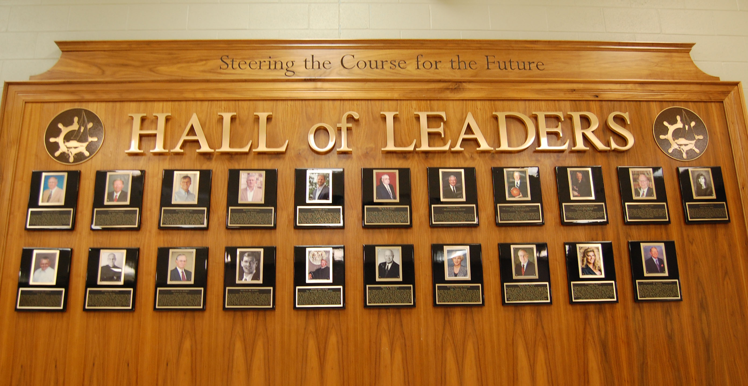

*Hall of Leaders display at Camdenton High School. Nomination deadline for 2016 recognition is Friday, November 6, 2015.*

Contact: Marsha Schoeneman

Foundation PR/Communications Chairperson

Mobile: 573-480-4669

Foundation email: camdenton_edu_foundation@yahoo.com